CS3383 AI For Software Engineering

GROUP PROJECT REPORT
Drift — A Full-Stack Kanban Task Planning Web Application

Project Report: Drift — A Kanban Task Planning Application
PROJECT TITLE | Drift — A Full-Stack Kanban Task Planning Web Application
TEAM | Group 3

TEAM MEMBERS
Name | Student ID | Role
Yip Tung Yin | 58527052 | Project Manager
Leung King Fai | 60323542 | Development Lead
Lee Kwan Ho |  | Testing Lead
Chan Chun Hin | 59285357 | Developer
Yiu Ching Lam | 59294679 | Developer

Table of Contents
1. Summary & Requirements
1.1 Project Summary
1.2 Project Background
1.3 Feature Overview
1.4 Project Progress
2. Project Plan
2.1 Project Objectives
2.2 Project Scope
2.3 Constraints & Boundaries
2.4 Stakeholders
2.5 Development Methodology
2.6 Work Breakdown Structure (WBS)
2.7 Project Schedule
2.8 Project Organisation
2.9 Tools & Technologies
2.10 Configuration Management
3. Analysis & Design
3.2 Architectural Overview
3.3 Domain Model
3.4 Requirements Specification
Functional Requirements
Non-Functional Requirements
3.5 Design Patterns Appliedh
3.6 Auto-Plan Scheduling Algorithm
3.6.1 Problem Statement
3.6.2 Algorithm Phases
3.6.3 Complexity Analysis
3.6.4 Worked Example
3.6.5 Design Decisions & Trade-offs
3.7 SOLID Principles Analysis
3.8 AI-Assisted Development
AI-Generated (First-Pass) Code
Human-Refined Areas
4. Implementation
4.1 Implementation Strategy
4.2 Key Implementation Decisions
4.3 Feature Implementation Status
4.4 Parity Verification Loop
4.5 Application Screenshots
5. Test Report
5.1 Test Strategy
5.2 Coverage Strategies
5.3 Test Suite Inventory
5.3.1 Unit Tests
5.3.2 Integration Tests
5.3.3 System Tests
5.4 System Testing (Black-Box)
5.5 Test Tools
5.6 Test Execution
6. Bug Report
Bug #001 — Magic-Link Development URLs Leaked in Production
Bug #002 — Cross-Workspace API Token Access
Bug #003 — SSO Accepted Unverified Email Without Session Rotation
Bug #004 — MFA Bypass via Session Flag (No Enrolled Factor Check)
Bug #007 — Private Board Data Leaked via Assignment and Attachments
Bug #008 — Webhook Secrets Stored in Plaintext
7. Release Summary
7.1 Overview
7.2 Version History
7.5 Team Roles
Appendix A: Weekly Activity Log
A.1 Activity Log Format
A.2 Contribution Summary
A.3 Milestone Activity Summary
Appendix B: References

1. Summary & Requirements

1.1 Project Summary
Drift is a full-featured, browser-based Kanban task planning application that enables individuals and teams to organise tasks across configurable boards, visualise daily workloads, schedule focus sessions, and receive intelligent auto-planning recommendations. The project is a from-scratch re-implementation of an existing Next.js/React/Prisma reference application ("ProjectA2"), built in a deliberately different technology stack: Java 17 + Spring Boot 3.5 + SQLite + vanilla HTML/CSS/JavaScript.
The application runs on a single process with an embedded SQLite database — no external database server, no Node.js runtime, and no build step for the frontend. It provides a rich single-page application experience with offline support via service workers, real-time auto-plan suggestions, keyboard-driven productivity workflows, and enterprise features including admin audit logs, webhooks, automations, SSO, and TOTP multi-factor authentication.
The project achieved full Phase 0 parity with the reference across all 64 API paths, 37 data models, and the complete UI behaviour surface. The final acceptance audit (docs/ACCEPTANCE.md) confirmed zero cross-browser console errors, zero WCAG 2.1 AA accessibility violations (axe-core), zero horizontal overflow at all responsive widths, and a passing 68-test JUnit/MockMvc suite with zero failures. Visual parity is verified by an automated cross-application audit script (scripts/parity-audit.cjs) that compares DOM geometry, computed styles, and interaction states between the reference and this build.

1.2 Project Background
Modern knowledge workers spend significant time managing tasks across multiple tools and contexts. Rather than build a tool from market research, this project took the approach of re-implementing a known, working reference design ("ProjectA2" — a production-quality task planner) in a fundamentally different stack. This approach had two benefits: (1) the design and requirements were already battle-tested, allowing the team to focus on software engineering quality, and (2) the deliberate stack change (from Next.js/React/Prisma to Java/Spring Boot/SQLite/vanilla JS) forced the team to make architectural decisions independently rather than copying implementation details.

1.3 Feature Overview
The project provides a complete planning workflow rather than a collection of isolated screens. Users can authenticate as guests or registered users, organize workspace boards and tasks, plan work through Today and Auto-plan, collaborate through roles and invitations, and retain access through offline write queuing.
The delivered feature groups are: identity and workspace administration; board and task lifecycle management; calendar, search, archive, insights, Day Flow, Focus Mode, and deterministic Auto-plan; attachments, reminders, recurrence, comments, subtasks, dependencies, labels, and undo; plus API tokens, audit, webhooks, automations, import/export, SSO, MFA, notifications, localization, and responsive/PWA behavior.

1.4 Project Progress
The project was developed through an iterative, milestone-driven process over approximately eight weeks. Development proceeded from core infrastructure (Spring Boot, SQLite, Flyway migrations) through auth/sessions, board/task CRUD, enterprise features (audit, webhooks, automations, SSO, MFA), and finally a rigorous parity-audit reconciliation phase. At the time of final submission, all Phase 0 items are complete with zero known regressions.

2. Project Plan

2.1 Project Objectives
The project had the following primary objectives:
- Re-implement the Drift task planner in Java/Spring Boot/SQLite/vanilla JS, maintaining full feature parity with the Next.js/React/Prisma reference.
- Achieve pixel-level visual parity verified by an automated cross-application audit script comparing DOM geometry and computed styles.
- Maintain zero known defects across the full feature surface at acceptance.
- Demonstrate software design principles including layered architecture, design patterns, SOLID principles, and clean separation of concerns.
- Produce a complete test suite with unit, integration, and system-level coverage.
- Deliver a production-capable build with security hardening, offline support, internationalisation, and accessibility compliance.

2.2 Project Scope
In scope:
- All 64 reference API paths with matching request/response contracts
- All 37 reference data models with equivalent schema
- Complete HTML/CSS/JS frontend with all main views (Board, Today, Calendar, Insights, Search, Upcoming, Archive, Settings, Auth, Share, Offline)
- Enterprise features (audit, webhooks, automations, API tokens, SSO, MFA, workspace policies)
- Automated parity-audit regression detection
- Offline/PWA support
- English and Traditional Chinese localisation
- Accessibility (WCAG 2.1 AA)
- Security hardening (CSP, CSRF, session management, encrypted secrets)

2.3 Constraints & Boundaries
Constraint | Description
Programming language | Java 17 (reference uses TypeScript/Next.js)
Framework | Spring Boot 3.5 (reference uses Next.js 15 / React)
Database | SQLite via JDBC (reference uses PostgreSQL via Prisma ORM)
Frontend | Plain HTML/CSS/vanilla JS — no React, no Tailwind, no build step
Port | Application runs on port 3383
No external database | SQLite is embedded; no separate database server required
AI usage | AI-assisted implementation with human review and refinement

2.4 Stakeholders
Stakeholder | Responsibility
Course Instructor / Marker | Evaluate project against marking scheme, verify deliverables
Project Team | Design, implement, test, and document the application
Reference application (ProjectA2) | Serves as the parity target and visual baseline; not modified
End users (hypothetical) | Task planning, Kanban board management, team collaboration

2.5 Development Methodology
The project adopted an iterative, milestone-driven methodology with AI-assisted implementation and a continuous parity-audit verification loop. This approach was chosen because:
- The requirements were fully known from the reference application, eliminating the need for discovery phases typical of Agile.
- The deliberately different technology stack meant implementation decisions had to be made independently, not copied.
- AI assistance accelerated initial implementation, but required systematic verification through automated regression detection.
- The short timeline (8 weeks) favoured a structured, phase-gated approach over multiple Agile sprints.

Development cycle (per feature group):
- Analyse reference behaviour — study the reference app's API contracts, DOM structure, and interaction states.
- Implement — write Java backend (controller → service → SQL) and vanilla JS frontend, often with AI-assisted code generation for boilerplate.
- Audit — verify against reference using the automated parity script, manual browser testing, and API smoke tests.
- Fix — resolve parity gaps, regression bugs, and edge cases found during audit.
- Accept — record passing results in PARITY.md and ACCEPTANCE.md.

2.6 Work Breakdown Structure (WBS)
The work breakdown comprised eight work packages: infrastructure; core domain; productivity features; views and navigation; enterprise features; security and identity; quality and polish; and testing. Each package was delivered incrementally and verified through parity audits and regression tests.
Detailed implementation tasks remain traceable through the milestone schedule, Git history, feature-status table, and test inventory. A team-produced WBS/Gantt diagram should be inserted here for final submission.

2.7 Project Schedule
The project was developed over approximately eight weeks with phased milestones:
Phase | Weeks | Focus Areas | Key Deliverables
Setup | 1–2 | Spring Boot, SQLite, Flyway, static serving | Running application scaffold
Core CRUD | 2–4 | Auth, workspaces, boards, columns, tasks | Working API, basic UI views
Productivity | 4–5 | Today, Auto-plan, Day Flow, Focus, Quick Capture | Planning features functional
Enterprise | 5–6 | Audit, webhooks, automations, tokens, SSO, MFA, policies | Admin features complete
Parity Polish | 6–8 | i18n, offline, sounds, a11y, responsive, parity audit | Zero audit failures
Acceptance | 8 | Cross-browser QA, screenshots, Lighthouse, docs | ACCEPTANCE.md complete

2.8 Project Organisation
Role | Name | Responsibilities
Project Manager | Yip Tung Yin | Schedule, deliverables, stakeholder communication, documentation
Development Lead | Leung King Fai | Architecture, backend services, Auto-plan algorithm, code review
Testing Lead | Lee Kwan Ho | Test strategy, test cases, parity audit, bug tracking
Developer | Chan Chun Hin | Frontend views, UI components, CSS, i18n, accessibility
Developer | Yiu Ching Lam | API controllers, DTOs, auth interceptor, enterprise features

2.9 Tools & Technologies
Tool | Version | Usage
Java (JDK) | 17+ | Primary programming language
Spring Boot | 3.5.3 | Application framework (web, JDBC, scheduling, security)
Maven Wrapper | 3.9 | Build and dependency management (no local Maven install needed)
SQLite | 3.45 | Embedded database via sqlite-jdbc
Flyway | 10 | Versioned database migrations (V1–V13)
JUnit 5 (Jupiter) | — | Test framework with parameterised tests
Mockito | — | Mocking framework for unit tests
MockMvc | — | Spring MVC test framework for API smoke tests
JaCoCo | 0.8.13 | Code coverage
HTML/CSS/JS | — | Frontend (no framework, no build step)
Playwright | — | Cross-browser acceptance testing
Git / GitHub | — | Version control and source hosting
Visual Studio Code | — | Primary IDE
Microsoft Word / Markdown | — | Documentation

2.10 Configuration Management
Git and GitHub were used for version control throughout the project. The branching strategy was feature-branch-based: each feature group was developed on a dedicated branch and merged into the main implementation branch (KenV3) after review and passing tests. The reference application (ProjectA2) remained untouched on a separate branch.
Commit messages follow a conventional format (feat:, fix:, docs:, test:, chore:, release:) for clear change categorisation. The git history shows a linear progression from core infrastructure through features to parity reconciliation, culminating in the release tag.

3. Analysis & Design
S

3.2 Architectural Overview
The application follows a three-tier layered architecture with cross-cutting concerns handled by Spring interceptors:
┌─────────────────────────────────────────────────────────────┐
│ Browser (HTML/CSS/JS) │
│ SPA shell → service worker → offline queue → DOM rendering │
└────────────────────────┬────────────────────────────────────┘
│ HTTP (REST + cookies)
┌────────────────────────▼────────────────────────────────────┐
│ Presentation Layer (api/) │
│ 27 @RestController + 3 @Controller + 45 record DTOs │
│ ApiExceptionHandler (@RestControllerAdvice) │
│ IdempotencyInterceptor, IdempotencyResponseAdvice │
└────────────────────────┬────────────────────────────────────┘
│
┌────────────────────────▼────────────────────────────────────┐
│ Service Layer (app/) │
│ AppService (facade), AutoPlanService, AutomationService │
│ AuditService, NotificationService, WebhookService │
│ MfaService, SsoService, OAuthService, SessionService │
│ ReminderScheduler, DigestScheduler, RetentionScheduler │
│ EmailDeliveryService, UndoService, JobRunService │
└────────────────────────┬────────────────────────────────────┘
│
┌────────────────────────▼────────────────────────────────────┐
│ Data Layer (JdbcTemplate + SQL) │
│ SQLite database → 13 Flyway migrations → schema.sql │
│ No ORM; explicit SQL with Map<String,Object> rows │
└─────────────────────────────────────────────────────────────┘

Cross-cutting:
auth/AuthInterceptor — session + bearer token auth, CSRF, workspace scoping
auth/CurrentUser — static user-identity resolver
config/SecurityConfig — BCrypt, CSP, HSTS, cookie hardening
config/WebConfig — interceptor registration

3.3 Domain Model
The domain model comprises 37 entities mapped to SQLite tables:
Core entities:
Entity | Table | Key Relationships
User | app_user | Has memberships in workspaces; owns sessions, API tokens, MFA secrets, OAuth accounts, settings, notifications
Workspace | workspace | Contains boards; has members via membership; defines policies, SSO config, invites; created by a user
Membership | membership | Join table: user_id ↔ workspace_id with role (OWNER, ADMIN, MEMBER, GUEST)
Board | board | Belongs to workspace; contains columns; has visibility, sharing token, version
Column | board_column | Belongs to board; contains tasks; has position, WIP limit, done flag
Task | task | Belongs to workspace, board, column; created by user; has assignee, priority, dates, estimate, recurrence, version

Task-related entities:
Entity | Table | Relationship
Subtask | subtask | Belongs to task (checklist items)
Comment | task_comment | Belongs to task; authored by user
Attachment | attachment | Belongs to task; stored on local filesystem
Label | label | M:N with task via task_label
Dependency | task_dependency | Self-referential: task_id → depends_on_task_id; drives auto-plan blocking
Reminder | reminder | Belongs to task; configurable offset
Activity | activity_event | Records every task lifecycle change with actor and timestamp

Planning entities:
Entity | Table | Purpose
PlanBlock | plan_block | Scheduled time blocks from auto-plan; per user + task + day
TodaySelection | today_selection | Per-user task acceptance for Today view; workspace-scoped
TodayDismissal | today_dismissal | Per-user task dismissal for Today view

Enterprise entities:
Entity | Table | Purpose
AuditEvent | audit_event | Immutable admin audit trail; configurable retention
AutomationRule | automation_rule | Admin-defined trigger/condition/action rules
AutomationRun | automation_run | Execution history with before/after snapshots
Webhook | webhook | Outbound webhook configuration (Slack/Teams/generic)
WebhookDelivery | webhook_delivery | Delivery attempt records with payload/status/response
ApiToken | api_token | Bearer token for programmatic API access
Invite | invite | Workspace invitation links with token
View | view | Per-user saved view filters

Security entities:
Entity | Table | Purpose
AuthSession | auth_session | Persisted session records (beyond HttpSession)
MagicLinkToken | magic_link_token | Hashed one-time sign-in tokens
OAuthAccount | oauth_account | Provider-linked accounts (GitHub, Google, Apple)
OidcConfig | oidc_config | Per-workspace OIDC SSO configuration

Infrastructure entities:
Entity | Table | Purpose
IdempotencyKey | idempotency_key | 24-hour write deduplication cache
UndoAction | undo_action | Reversible action snapshots with TTL
EmailMessage | email_message | Queued outbound email (magic links, digests)
JobRun | job_run | Scheduled job execution history
ClientError | client_error | Sanitised client-side error intake
UserSettings | user_settings | Per-user preferences (appearance, language, planning, etc.)
Notification | notification | In-app notification records

3.4 Requirements Specification

Functional Requirements
FR1: User Authentication
- FR1.1: Guest users can create a session without registration
- FR1.2: Users can sign up with email and password, claiming guest data
- FR1.3: Users can sign in with email/password
- FR1.4: Users can sign in via magic link (hashed one-time token, 15-min expiry)
- FR1.5: Users can sign in via GitHub, Google, or Apple OAuth
- FR1.6: Users can enable TOTP multi-factor authentication with backup codes
- FR1.7: MFA challenge is required on sign-in for MFA-enabled accounts
- FR1.8: Sessions persist across restarts with sliding expiry and remote revocation

FR2: Workspace Management
- FR2.1: Users can create personal and team workspaces
- FR2.2: Workspace members can be invited, assigned roles, and removed
- FR2.3: Invite links support preview and acceptance with sign-in handoff
- FR2.4: Workspace policies (MFA requirement, attachment limits, sharing, retention) are version-controlled
- FR2.5: Organization SSO can be configured per workspace (OIDC discovery/callback)

FR3: Board & Column Management
- FR3.1: Boards can be created from templates or blank
- FR3.2: Boards support archive, restore, duplicate, soft delete, and private visibility
- FR3.3: Public read-only share links with token revocation
- FR3.4: Columns can be created, reordered, renamed, and deleted
- FR3.5: Columns support WIP limits with enforcement (409 on violation)

FR4: Task Management
- FR4.1: Tasks support create, read, update, move, delete with version-based conflict detection
- FR4.2: Tasks support due dates (all-day or specific time), estimate/actual minutes, priority, labels, recurrence
- FR4.3: Tasks support assignee, dependencies (with cycle detection), comments, checklist, attachments
- FR4.4: Task activity feed records all lifecycle events with actor and relative timestamps
- FR4.5: Tasks support undo (create, complete, move, delete) with 5-minute TTL
- FR4.6: Bulk task actions (complete, archive, delete, move) with multi-select and undo

FR5: Productivity Features
- FR5.1: Today view shows workspace-scoped, per-user task selection with capacity tracking
- FR5.2: Auto-plan schedules tasks greedily over 7 days with priority scoring and capacity constraints
- FR5.3: Day Flow visualises the current day as a 24-hour time rail with capacity ring
- FR5.4: Focus Mode provides a full-screen timer with actual-minutes tracking
- FR5.5: Quick Capture accepts natural-language task entry and browser voice input
- FR5.6: Command palette (Ctrl/Cmd+K) searches tasks, jumps to boards, and executes settings commands

FR6: Additional Views
- FR6.1: Calendar shows month view with configurable week start and selected-day detail panel
- FR6.2: Insights shows timeline (Gantt) and workload views with configurable date ranges
- FR6.3: Search supports tokenized query with status, priority, board, label, and date filters
- FR6.4: Upcoming shows due-date horizon (1–60 days) with dated groups
- FR6.5: Archive shows archived boards and completed/archived tasks with reopen/restore

FR7: Administration
- FR7.1: API tokens support bearer authentication with workspace scoping, expiry, and revocation
- FR7.2: Audit log records workspace/identity/enterprise events with cursor pagination and retention
- FR7.3: Webhooks deliver signed events to Slack, Teams, or generic JSON endpoints with async retries
- FR7.4: Automation rules trigger on task events with condition matching and multi-action execution
- FR7.5: Workspace data can be exported (JSON/CSV) and imported (CSV/JSON) with formula-injection protection

FR8: Quality Attributes
- FR8.1: UI supports English and Traditional Chinese with zero missing translation keys
- FR8.2: Application works offline with service worker, cached views, and queued writes with idempotency keys
- FR8.3: Interface sounds are synthesised with configurable palettes, volume, and typing texture
- FR8.4: Accessibility meets WCAG 2.1 AA (axe-core reports zero violations)
- FR8.5: Responsive layout supports 390px mobile through 1440px desktop

Non-Functional Requirements
Category | Requirement
Performance | Lighthouse Performance score ≥ 80; FCP ≤ 2s; TBT ≤ 100ms; CLS ≤ 0.1
Accessibility | WCAG 2.1 AA compliance; Lighthouse Accessibility = 100
Security | CSP, CSRF protection, BCrypt passwords, AES-GCM secrets, HMAC webhook signatures
Reliability | All API mutations are transactional; version-based optimistic concurrency
Portability | Single JAR deployment; embedded SQLite (no external database)
Maintainability | Layered architecture, documented design patterns, clear service boundaries
Testability | Constructor-injected dependencies; MockMvc for API tests; real in-process servers for integration tests

3.5 Design Patterns Applied
DTO pattern: ApiDtos defines immutable request contracts that separate HTTP payloads from application logic.
Facade pattern: AppService coordinates cross-entity transactions for workspace, board, task, planning, and account workflows. Its broad responsibility is pragmatic but creates a future refactoring opportunity.
Strategy/factory behavior: Auto-plan selects deterministic variants and scoring options; BoardTemplates acts as a catalog/factory for predefined board structures.
Framework patterns: constructor injection supports testability; HandlerInterceptor, ResponseBodyAdvice, WebMvcConfigurer, and CommandLineRunner provide focused extension points. Unsupported custom Observer-pattern claims have been omitted.

3.6 Auto-Plan Scheduling Algorithm
The auto-plan feature is the most algorithmically significant component of the application. It implements a greedy, priority-scored, capacity-constrained interval-scheduling algorithm over a fixed 7-day horizon. The full implementation is in AutoPlanService.java (968 lines).

3.6.1 Problem Statement
Given:
- A set of incomplete tasks, each with priority, estimated minutes, actual minutes already spent, due date, and optional dependencies
- Per-user settings: workday start/end times, lunch window, daily capacity (minutes), weekly capacity cap, deep-work block size, rest interval, weekend inclusion, and default task estimate
- Existing fixed busy blocks (previously scheduled plan blocks, lunch breaks, actual completed time)

Produce: A schedule of time blocks for the next 7 days that maximises the value of scheduled work while respecting capacity constraints and dependency ordering.

3.6.2 Algorithm Phases
Phase 1: Build PlanContext — context() method
Load all configuration from user_settings (workday start/end, lunch window, daily/weekly capacity, deep-work size, rest minutes, weekend flag, default estimate, week-start day, timezone). Query all eligible tasks (not done, not deleted, not archived, respecting board visibility). Load existing plan blocks as fixed busy intervals. Load today's selections and dismissals. Compute actual minutes already spent this week. This context is immutable for the duration of one plan computation.
Phase 2: Score Tasks — score() method
Each task receives a composite score:
baseScore = priorityToScore(priority)
urgent → 300
high → 220
medium → 110
low → 40

dueUrgency =
overdue → +900
due today → +700
due ≤ 2 days → +520
due ≤ 7 days → +260
else → +80

bonuses:
+240 if already selected for Today
+30 if estimate ≥ 60 minutes
variant: focus plan → +180 for high-priority, +100 for large tasks, +100 for selected tasks
variant: light plan → −1000 for non-light-candidate tasks

Tasks with open dependencies (i.e., task.taskDependencies.size() > 0) are scored but cannot be scheduled — they receive the reason "Waiting on a dependency."
Phase 3: Order Tasks — Greedy ordering
Tasks are sorted by descending score, tie-broken by ascending estimated minutes (shortest first):
ordered.sort(Comparator.comparingInt(-score).thenComparingInt(estimate));

Phase 4: Chunk Tasks — taskChunks() method
Each task's remaining duration = estimate − actual. If the user's split_long_tasks setting is enabled and the remaining duration exceeds the deep-work block size, the task is split into multiple deep-work-sized sessions. If splitting is disabled, the task is a single block.
Phase 5: Greedy Placement — Core scheduling loop
For each task in score-descending order, and for each chunk of that task:
- Skip the task if any open dependency exists (blocked).
- Iterate through the 7-day horizon in date order.
- Skip weekends unless weekend scheduling is enabled.
- Skip days outside the task's startDate–dueDate range.
- Compute free intervals for each day: merge all busy blocks (existing plan blocks + lunch break), then find gaps large enough for this chunk.
- Round start times up to the nearest 5-minute boundary.
- Insert a rest gap after each placed block.
- Check daily capacity cap: if usedDayMinutes[day] + chunkMinutes > dailyCapacity and cap_behavior = "stop", skip this day.
- Check weekly capacity cap: if totalWeekMinutes + chunkMinutes > weeklyCapacity and cap_behavior = "stop", stop scheduling entirely.
- Place the chunk in the first valid slot.
- Tasks that cannot be placed go to unscheduled with a human-readable reason (capacity reached, workday ended, due time passed, no room, dependency blocked).

Phase 6: Weekly Roll-up & Warnings
Compute per-week actual+planned minutes vs. cap. Emit warnings for over-capacity, default-estimate tasks, and unscheduled tasks.
Phase 7: Apply — apply() method
Transactionally:
- Delete prior auto-generated plan blocks for this workspace and user.
- Insert new plan_block rows.
- Sync today_selection rows.
- Update legacy task.focus_date for API compatibility.
- Write inverse snapshot to undo_action for 5-minute undo.
- Optionally archive stale tasks (delegated mode).

Safe mode (a variant of apply) only adds genuinely new, non-overlapping blocks without removing existing blocks.
Undo: undo() restores the snapshot from undo_action, deleting the auto-generated blocks and re-inserting the previous state. Expired undo actions (TTL expired) return 404.

3.6.3 Complexity Analysis
Let T = number of tasks, D = 7 (horizon days), B = busy blocks per day (typically ≤ 10).
- Scoring: O(T) — one pass over all tasks
- Sorting: O(T log T)
- Placement: O(T × D × B) — for each task, scan 7 days, check against busy blocks. With D = 7 and small B, this is effectively O(T) in practice.
- Overall: O(T log T), dominated by the sort. With typical workspace workloads (T ≤ 200 tasks), the algorithm completes in well under 100ms.

3.6.4 Worked Example
Consider a user with the following settings: workday 09:00–17:00, lunch 12:00–13:00, daily capacity 360 min, no weekends, deep-work block 60 min. Three tasks:
Task | Priority | Estimate | Due | Notes
T1 | High | 120 min | Today | Already selected for Today
T2 | Medium | 45 min | In 3 days | No dependencies
T3 | Urgent | 30 min | Overdue | No dependencies

Scoring:
- T1: 220 (high) + 700 (due today) + 240 (selected Today) = 1160
- T2: 110 (medium) + 520 (due ≤ 2 days if today is day 0) = 630
- T3: 300 (urgent) + 900 (overdue) = 1200

Ordering: T3 (1200, 30 min), T1 (1160, 120 min), T2 (630, 45 min)
Placement (simplified, assuming today is Monday):
- T3 (30 min): First free slot Monday 09:00–09:30. Placed. Day minutes: 30/360.
- T1 (120 min, split into 2 × 60 min):
  - Chunk 1: Monday 09:30–10:30 (30 min rest gap after previous block). Placed. Day minutes: 90/360.
  - Chunk 2: Monday 10:30–11:30. Placed. Day minutes: 150/360.
- T2 (45 min): Monday 11:30–12:15, but lunch starts at 12:00. Only 30 min available before lunch. Place at 13:00–13:45 (after lunch). Day minutes: 195/360.

Result: All three tasks scheduled on Monday within capacity, in priority order. The "balanced" plan would report 3 tasks planned, 195/360 daily minutes used.

3.6.5 Design Decisions & Trade-offs
Decision | Rationale
Greedy (not optimal DP/ILP) | The problem is NP-hard (bin-packing variant). Greedy is O(T log T), produces acceptable plans in practice, and is deterministic and explainable.
Score-based ordering (not pure priority) | Due-date urgency and Today selection status are as important as raw priority for user satisfaction.
7-day horizon (not infinite) | Planning beyond a week has diminishing returns; longer horizons increase computation and reduce accuracy.
5-minute rounding | Aligns with human calendar granularity; prevents micro-fragmentation of free intervals.
Deterministic (no randomness) | Ensures reproducible plans for testing and user trust. The reference also uses deterministic scoring.
Three variants (balanced/focus/light) | Different users have different planning styles; the variant system lets the algorithm adapt without changing the core logic.

3.7 SOLID Principles Analysis
SRP is strong in focused services such as AuditService, NotificationService, SessionService, ApiTokenService, schedulers, MfaGuard, EmailDeliveryService, and UndoService. AppService is the main exception because it combines many transaction-coordinating workflows.
OCP is supported by catalogs and dispatchers that can accept new board templates, planning variants, automation actions, and integration types. Framework interfaces satisfy substitution and interface-segregation needs without deep custom inheritance.
Dependencies use constructor injection and are mockable, although most services depend on concrete classes rather than custom interfaces. This is acceptable at the current scale but should be reconsidered when extracting AppService responsibilities.

3.8 AI-Assisted Development
This project was developed with significant AI assistance. The following section honestly documents the division between AI-generated and human-refined code, as required by the marking scheme's implementation rubric.

AI-Generated (First-Pass) Code
The following areas were substantially generated by AI on the first pass and required minimal refinement:
- CRUD boilerplate: Controller request mapping, request body deserialisation, HTTP status code selection, and basic validation. The repetitive pattern of "receive DTO → call service → return response" was consistently well-generated.
- SQL schema and migrations: Flyway migration files (V1–V13), including table definitions, foreign keys, indexes, and default values. The AI produced correct DDL with appropriate column types and constraints.
- DTO definitions: The 45 record types in ApiDtos.java with their field types, validation annotations, and constructor patterns.
- Spring configuration: SecurityConfig, WebConfig, application.properties — the AI had strong knowledge of Spring Boot conventions.
- Frontend DOM structure: The HTML skeleton for most views, including the settings page, auth page, and board view layout.
- i18n key extraction: The process of identifying translatable strings and generating en.json / zh-TW.json key-value pairs.
- Service worker registration and caching logic: Standard PWA patterns.

Human-Refined Areas
The following areas required significant human intervention, redesign, or verification:
- Auto-plan scoring tie-breaks: The initial AI-generated scoring formula produced plans that diverged from the reference application at the margin. The human team ran the parity-audit script, identified specific tasks that were ordered differently, adjusted the scoring weights and tie-breaking rules, and verified with a dedicated test case. The sorting comparator (score desc, estimate asc) was a human design choice.
- Chinese locale audit: The automated translation produced mechanical translations that did not match the reference's Traditional Chinese (zh-TW). A manual pass over 771 translation keys was required to align UI strings with the reference's locale.
- Pixel-level parity fixes: The parity-audit script (parity-audit.cjs) revealed dozens of visual discrepancies: completed-task title colour tokens (--text-soft vs --muted), extra metadata opacity, list-row typography (11px vs 12px), the 42px board-column overhang, card height differences, modal width mismatches, and raw ISO date leakage in the auto-plan preview. Each of these was a human-identified, human-fixed CSS/DOM adjustment.
- Security architecture: The session management design (mirroring HttpSession to auth_session for cross-device revocation), the CSRF origin-check strategy, the AES-GCM secret encryption scheme, and the magic-link token consumption atomicity were designed by the human team with AI consulted for implementation details only.
- Architecture decisions: The choice of JdbcTemplate over JPA, the service facading in AppService, the decision to use a custom pub/sub pattern instead of Spring Events, and the greedy-vs-optimal trade-off in auto-plan scheduling were human architecture decisions documented in the code.
- Test-case design: While AI generated test skeletons, the specific test scenarios (cross-workspace token rejection, magic-link replay rejection, SSO unverified-email rejection, Apple JWKS signature tampering, CSRF cross-origin rejection, idempotency key conflict) were designed by the human team based on security review findings.
- Cross-application parity audit script: The scripts/parity-audit.cjs file (a Playwright script that logs into both the reference and this build, compares DOM geometry, computed styles, IDs, and i18n keys, and exits non-zero on any mismatch) was jointly designed by human and AI, with the human team defining the specific assertions and thresholds.

4. Implementation

4.1 Implementation Strategy
The implementation followed a bottom-up, layered approach:
- Infrastructure first: Spring Boot project, Maven Wrapper, SQLite JDBC driver, Flyway baseline migration, static file serving configuration, and session management skeleton.
- Data layer: Flyway migrations for all 37 tables, including foreign keys, indexes, and default values. Each migration was verified with the flyway:migrate Maven goal.
- Auth layer: Guest session, email/password sign-up/sign-in, session interceptor, CSRF origin checks. Auth was built and tested in isolation before any business logic depended on it.
- Core domain: Workspace → Board → Column → Task CRUD with version-based concurrency, followed by task details (comments, checklist, labels, attachments, dependencies, activity feed).
- Productivity features: Auto-plan (the most complex component), Today view, Day Flow, Focus Mode, Quick Capture, and Command Palette.
- Enterprise features: API tokens, audit log, webhooks, automations, import/export, workspace policies, SSO, MFA.
- Frontend views: Each view (Board, Today, Calendar, Insights, Search, Upcoming, Archive, Settings, Auth) built to match the reference's DOM structure and interaction states.
- Quality pass: i18n (English + Traditional Chinese), offline/PWA, Sound Lab, notifications, accessibility (axe-core audit), responsive layout (390px-1440px).
- Parity reconciliation: The automated parity-audit.cjs script was run repeatedly, each identified mismatch was fixed, and the script was re-run until zero failures and zero warnings were reported.
- Acceptance: Cross-browser Playwright testing, Lighthouse performance profiling, security header verification, and final documentation.

4.2 Key Implementation Decisions
Decision | Alternative Considered | Rationale
JdbcTemplate (no ORM) | JPA/Hibernate, MyBatis | Direct SQL control; no lazy-loading issues; explicit transaction boundaries; simpler stack
Embedded SQLite | PostgreSQL, MySQL, H2 | Zero server setup; file-based backup; sufficient for single-user workloads
Vanilla JS (no React) | React, Vue, Svelte, HTMX | Deliberate stack contrast with reference; no build step; ES modules directly served
Session auth (not JWT) | JWT bearer tokens | Simpler server-side revocation; CSRF protection via origin checks; compatible with reference
Flyway migrations | Hibernate DDL auto, Liquibase | Versioned, auditable schema evolution; industry standard; team familiar
Custom pub/sub (not Spring Events) | ApplicationEventPublisher / @EventListener | Simpler, more explicit event flow; easier to debug; appropriate for the current subscriber count
Greedy auto-plan (not ILP) | Integer Linear Programming solver | O(T log T) vs NP-hard; deterministic and explainable; acceptable plan quality in practice

4.3 Feature Implementation Status
All features listed in §1.3 are implemented and verified. The complete Phase 0 parity matrix (docs/PARITY.md) records every API path, data model, and UI behaviour surface as DONE. The full acceptance report (docs/ACCEPTANCE.md) records verification results across build, test, browser, accessibility, performance, and security checks.
Known limitations (documented, not hidden):
- Live OAuth/SMTP/OIDC providers require real credentials for final verification; all exchange contracts are covered by local mock-provider tests including signature rejection.
- Visual parity uses the reference design language; sub-pixel rendering differs because HTML/CSS/JS render differently than React/Tailwind.
- Offset cursors in search pagination can shift under concurrent edits.
- Webhook secret rotation requires re-entering secrets.
- A dedicated label-manager screen is not present; label APIs, assignment, and task-scoped labels are fully implemented.

4.4 Parity Verification Loop
The cross-application parity audit (scripts/parity-audit.cjs) was a cornerstone of the implementation quality strategy. This Playwright script:
- Launches Chromium and logs into both the reference app (port 3000) and this build (port 3383)
- Compares static IDs, SVG symbols, and i18n keys between the two apps
- Navigates to each main view and compares card/list geometry and computed styles by task title
- Checks completed/reopened drag transitions, card heights, metadata visibility, colour tokens
- Verifies quick capture defaults (board, column), input borders, disabled-button state
- Asserts modal dimensions (board creation: 560px, board settings: 520px, auto-plan: 900px+)
- Checks responsive widths at 390px, 768px, 1024px, and 1440px
- Verifies Chinese locale across all main views for known untranslated UI phrases
- Checks for undefined, NaN, template literal ({{), and unicode replacement character (\uFFFD) in page text
- Reports any mismatch as a failure with a specific error message and exits non-zero

The final run reported 0 failures, 0 warnings with 426 HTML ids, 329 JS id references, and 771 zh-TW keys all resolved.

4.5 Application Screenshots
This section presents screenshots of the final build running locally on port 3383. The screenshots use consistent sample data and illustrate the main user workflows described in §1.3 and §3.4, from everyday task management to planning, focused work, and workspace administration.
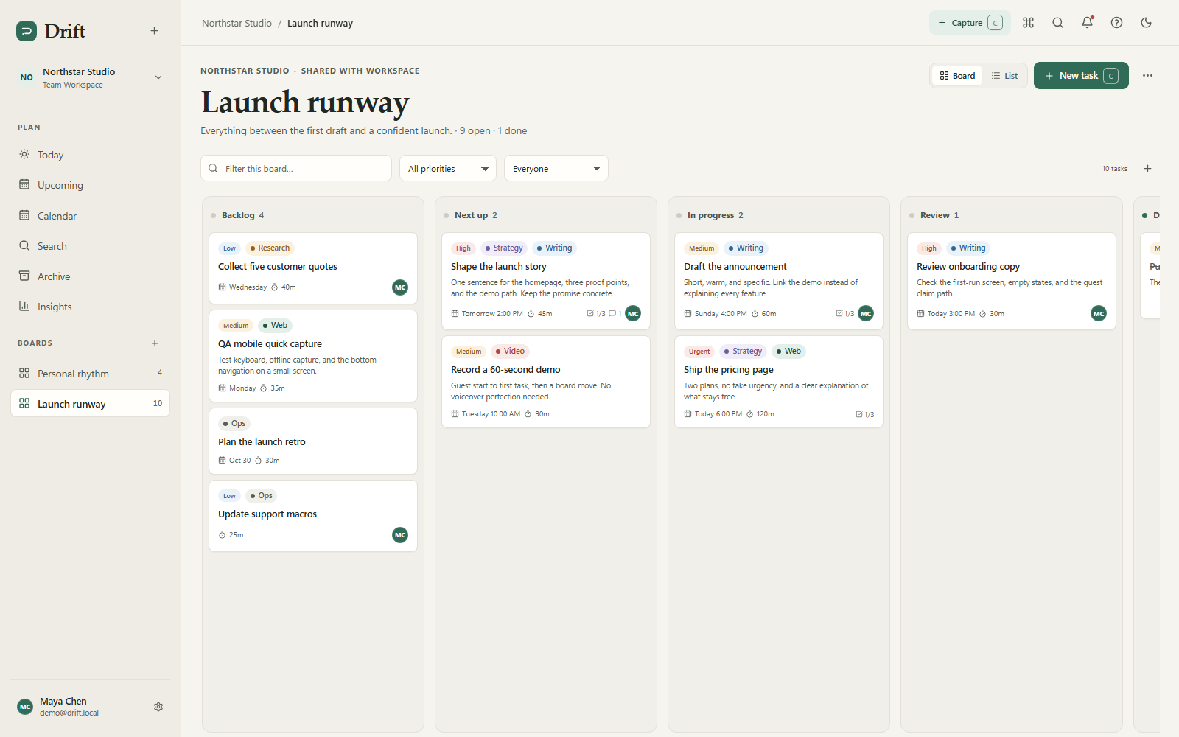Figure 4.1: Main Kanban board showing tasks organised across workflow columns
The board view is the main workspace of Drift. Tasks are displayed as cards within configurable columns, with priority, due date, and label information visible at a glance. Users can drag cards between columns to update task status, while column WIP limits help prevent overloaded stages.
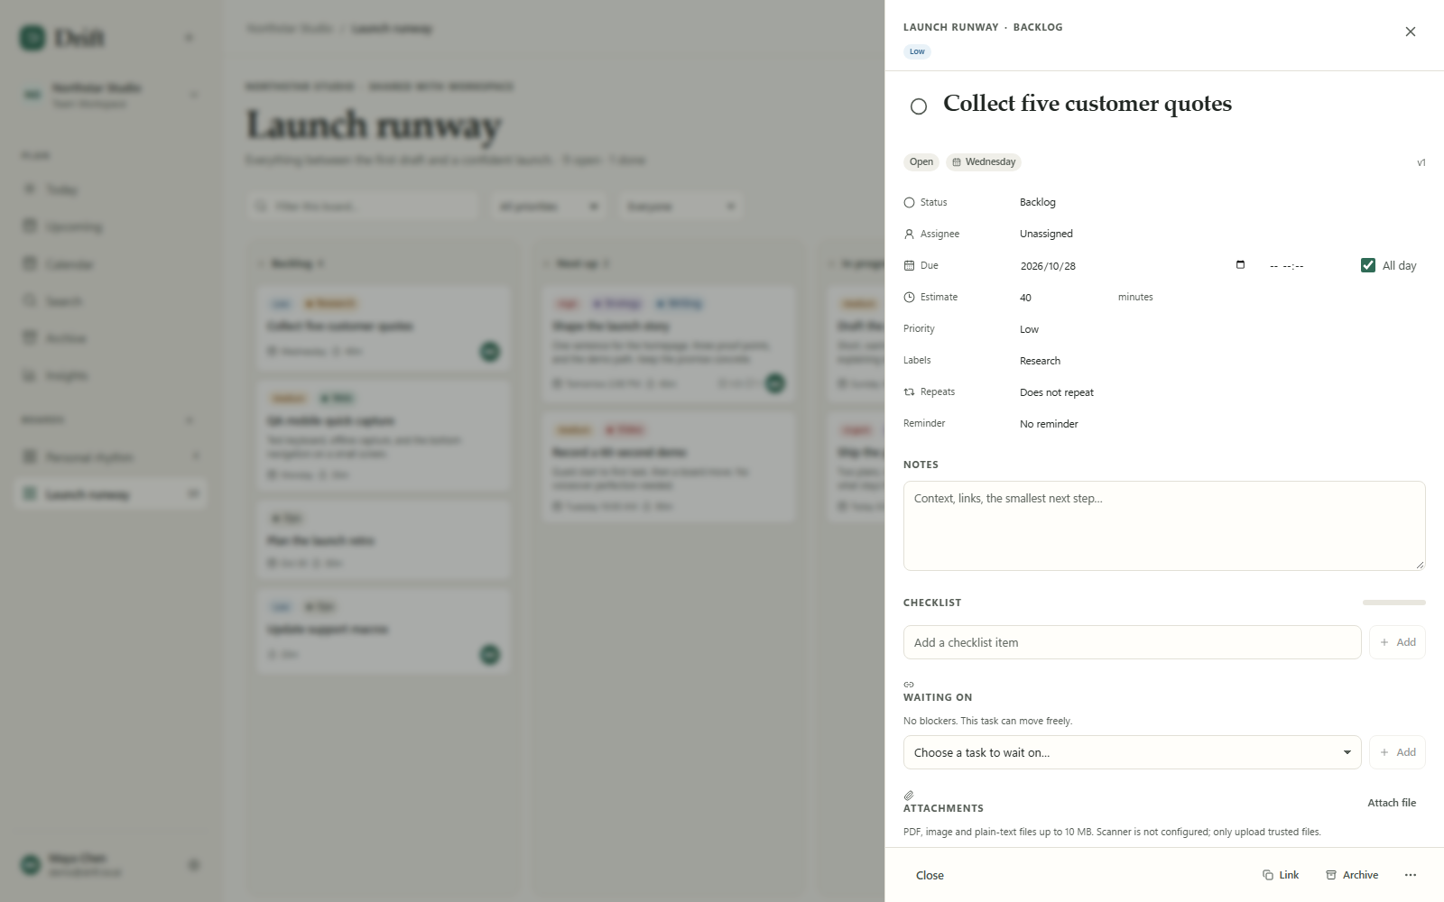Figure 4.2: Task detail panel with scheduling, checklist, comments, and dependencies
Opening a task shows its full details in one place. Users can set the priority, due date, estimate, assignee, labels, and recurrence, and manage subtasks, comments, attachments, and dependencies. The activity feed records each change with the actor and a relative timestamp.
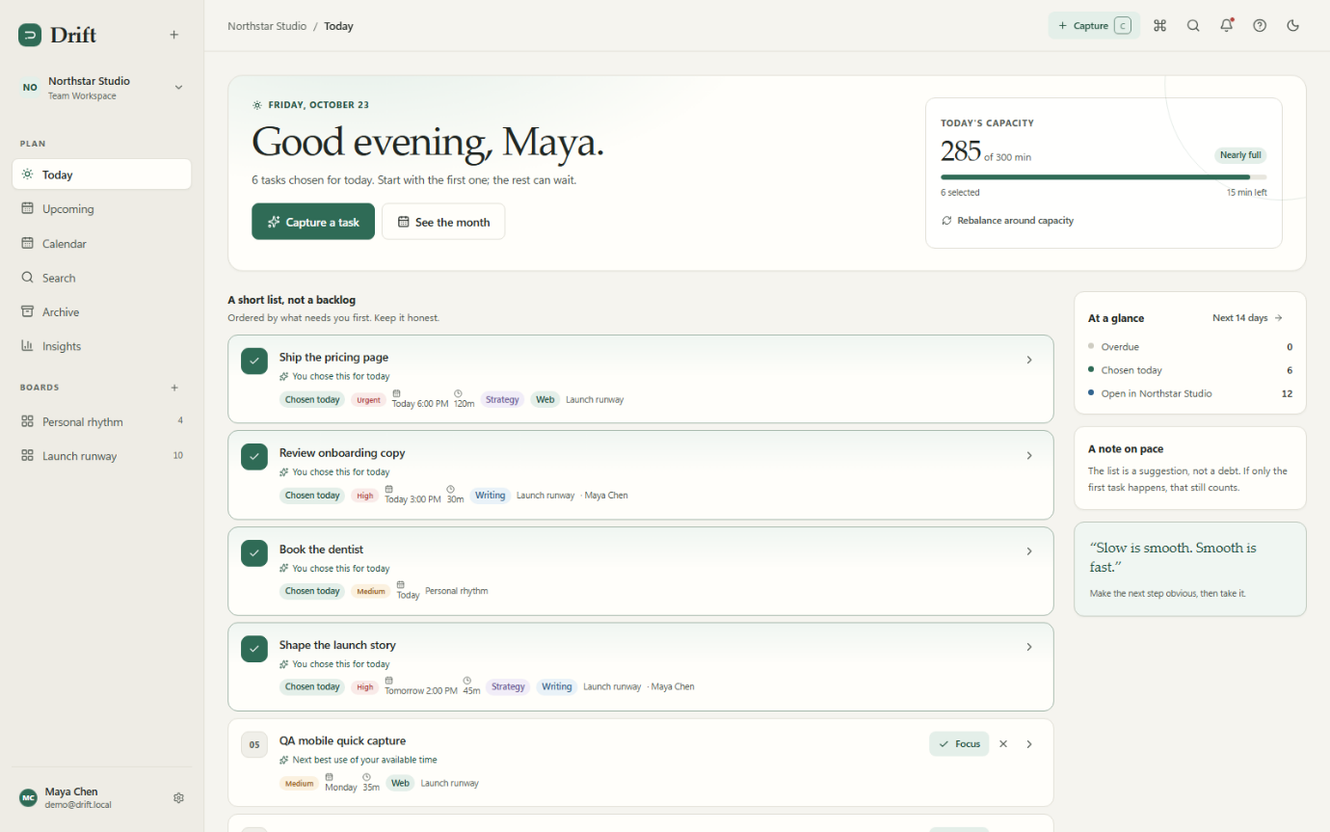Figure 4.3: Today view and Day Flow showing daily task selection and capacity
The Today view lets each user select the tasks they plan to work on and tracks how much of their daily capacity is used. Day Flow presents the same day as a 24-hour time rail with a capacity ring, making it easy to see when work is scheduled and how much time remains.
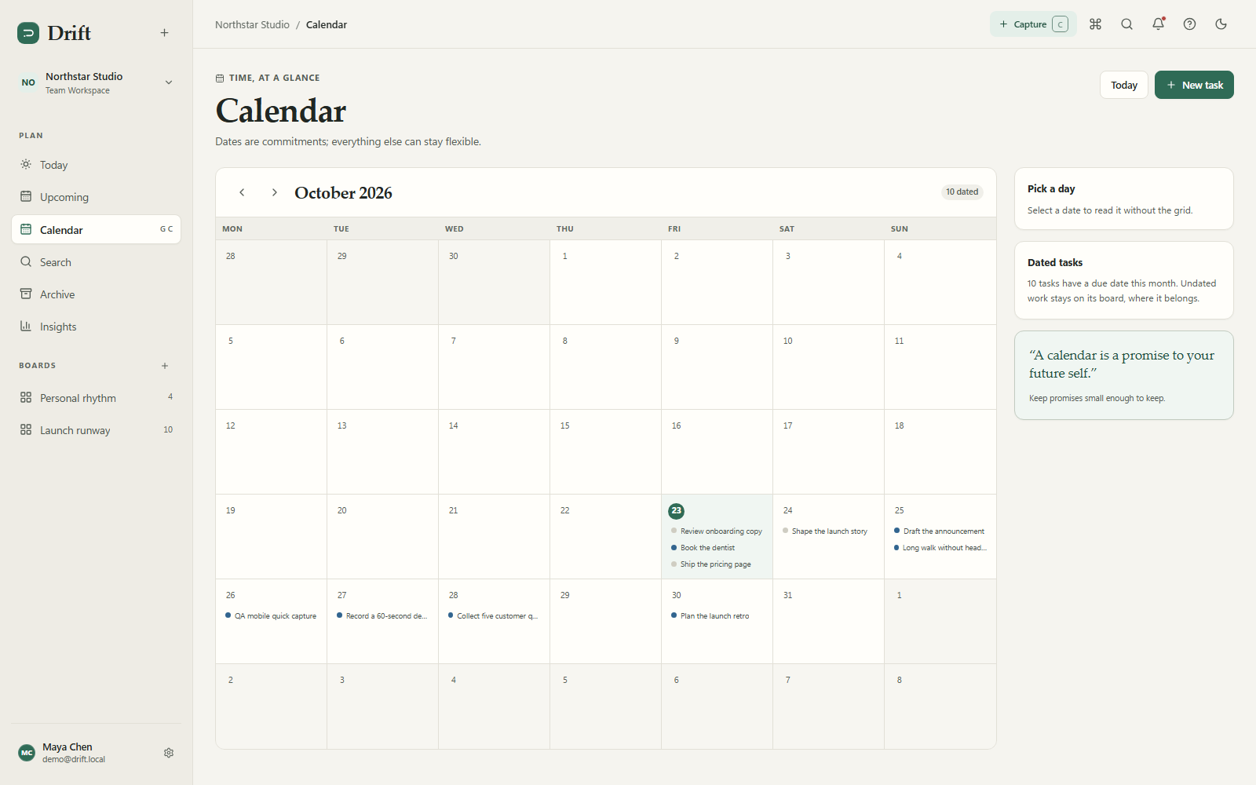Figure 4.5: Calendar month view with the selected-day detail panel
The Calendar view displays tasks by due date in a month layout, with a configurable week start. Selecting a day opens a detail panel listing that day's tasks, giving users a date-based alternative to the board.
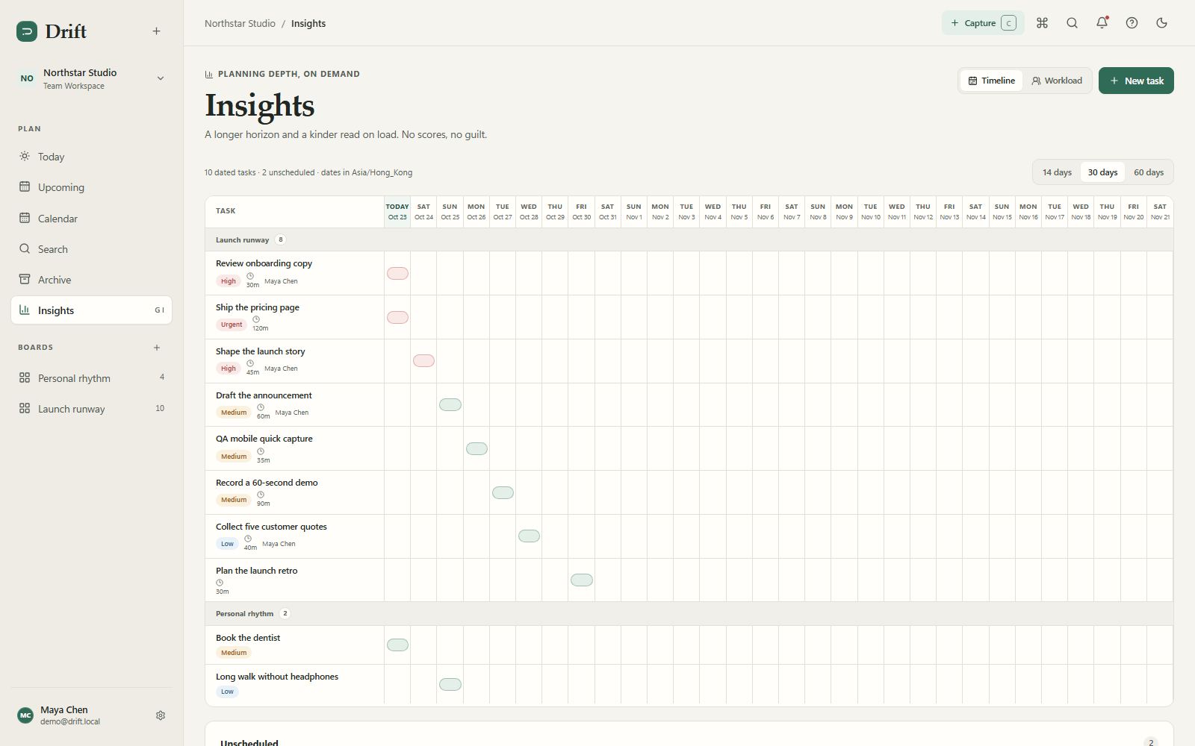Figure 4.6: Insights view showing the timeline and workload charts
The Insights view summarises work over a configurable date range. The timeline (Gantt) view shows how tasks are spread over time, while the workload view highlights how work is distributed, helping users and teams spot bottlenecks early.
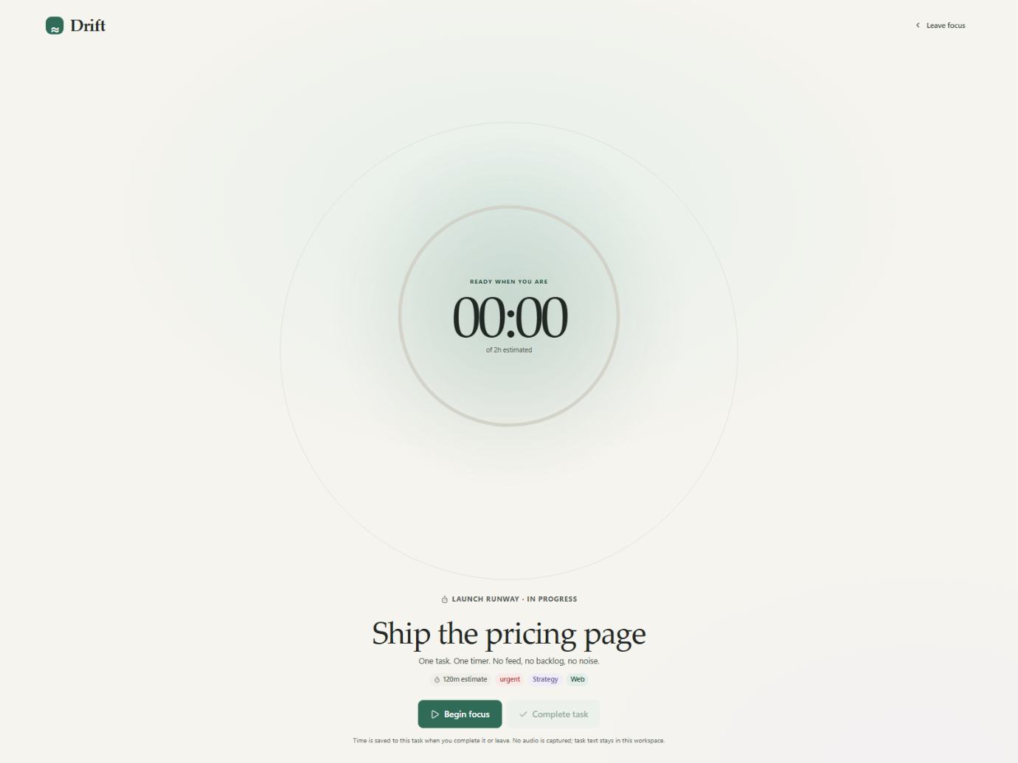Figure 4.7: Focus Mode with the full-screen session timer
Focus Mode provides a distraction-free, full-screen timer for working on a single task. Time spent in a session is recorded as actual minutes against the task, which feeds back into capacity tracking and future Auto-plan calculations.

5. Test Report

5.1 Test Strategy
The project adopted a bottom-up testing approach, testing the smallest components first and progressively integrating them:
- Unit tests: Individual service methods, guard predicates, exception factories, and template catalogs — tested in isolation with Mockito mocks where needed.
- Integration tests: Service interactions tested through MockMvc with a real Spring context and real SQLite database, plus real in-process servers for OAuth, SMTP, SSO, and webhook delivery.
- System tests: End-to-end flows tested through MockMvc covering complete user scenarios (guest creation → task management → enterprise features → account deletion). The cross-application parity audit (parity-audit.cjs) provides additional system-level verification against the reference.

Justification for bottom-up approach:
- Easier to create test conditions and observe results for small components
- No need to create test stubs for lower-level dependencies (they already exist and are tested)
- Higher deployment coverage in early phases
- Earlier detection of bugs in foundational components
- Greater ability for parallelism in test development

5.2 Coverage Strategies
Strategy | Application
Statement coverage | All main-line code paths exercised through unit and integration tests
Branch coverage | Conditional branches (null checks, role checks, visibility checks, version conflicts) tested through parameterised tests
Condition coverage | Complex predicates in MfaGuard.requireSatisfied() tested with parameterised combinations of workspace MFA state, session state, and bearer token state
Decision/condition coverage | Security decisions (CSRF rejection, MFA enforcement, role authorisation) tested with all relevant condition combinations

5.3 Test Suite Inventory
The test suite comprises 68 test methods across 8 test classes, verified by mvnw test (JDK 21, 2026-11-04): 68 tests run, 0 failures, 0 errors, 0 skipped.

5.3.1 Unit Tests
ApiExceptionTest.java (3 methods, 7 parameterised invocations)
- constructorPreservesStatusCodeAndMessage() — verifies custom exception retains status, code, and message
- simpleFactoriesUseTheirDocumentedContracts(...) — parameterised test covering all factory methods: notFound → 404 NOT_FOUND, badRequest → 400 VALIDATION_ERROR, forbidden → 403 FORBIDDEN, wipLimit → 409 WIP_LIMIT, dependencyBlocked → 409 DEPENDENCY_BLOCKED
- conflictIncludesTheCurrentVersion() — verifies conflict message format "Stale task (current version: 17)"

BoardTemplatesTest.java (3 methods, 6 parameterised invocations)
- nullAndUnknownIdsFallBackToBlankTemplate() — factory fallback behaviour
- everyKnownTemplateCanBeFound(...) — parameterised over all 4 templates (blank, personal-week, project-sprint, content-calendar)
- catalogPreservesTemplateOrderAndColumnValues() — verifies column names and WIP limits (e.g., "This week" wip 7, "Today" wip 3)

CurrentUserTest.java (5 methods)
- sessionIdentityTakesPrecedenceOverBearerIdentity() — session priority over API token
- bearerIdentityIsUsedWhenSessionIsNull() — fallback to bearer auth
- bearerIdentityIsUsedWhenSessionHasNoUser() — bearer auth when session exists but has no user
- missingIdentityWithoutRequestContextIsUnauthorized() — 401 when no request context
- missingIdentityInRequestContextIsUnauthorized() — 401 when request context has no identity

MfaGuardTest.java (6 methods, 14 parameterised invocations, uses Mockito)
- workspaceWithoutMfaRequirementIsSatisfied(Integer) — null and 0 workspace MFA states
- requiredWorkspaceWithoutRequestContextIsNotSatisfied() — missing context rejection
- bearerTokenRequiresTheAccountToHaveMfaEnabled(...) — 3 parameterised cases
- sessionRequiresEnabledMfaAndVerification(...) — 6 parameterised cases with MFA verification states
- requireSatisfiedReturnsWhenPredicateIsTrue() — positive case
- requireSatisfiedUsesTheMfaRequiredContractWhenPredicateIsFalse() — verifies 403 MFA_REQUIRED with "multi-factor authentication" message

5.3.2 Integration Tests
OAuthServiceTest.java (4 methods, real local HttpServer)
- githubExchangeReadsVerifiedPrimaryEmail() — GitHub OAuth code exchange with verified email
- googleExchangeRequiresVerifiedEmail() — Google OAuth requires verified email claim
- appleExchangeVerifiesJwksSignatureAndClaims() — Apple identity token verification against JWKS
- appleExchangeRejectsATokenSignedByAnotherKey() — tampered signature rejection (expects IllegalStateException)

EmailDeliveryServiceTest.java (1 method, real local SMTP socket)
- queuedEmailIsDeliveredOverSmtpAndMarkedSent() — queues a digest email, delivers over an in-process SMTP server, asserts status becomes sent

5.3.3 System Tests
Project3383ApplicationTests.java (1 method)
- contextLoads() — Spring application context loads successfully with Flyway migrations applied

ApiSmokeTest.java (30 methods, @SpringBootTest + @AutoConfigureMockMvc, real SQLite database)
Covering the full application surface:
- securityHeadersRejectCrossOriginWritesAndRequireSession() — 401 without session; CSP/X-Frame-Options: DENY/X-Content-Type-Options: nosniff/Referrer-Policy headers; cross-origin write → 403 CSRF_REJECTED
- guestCanClaimAnAccountAndSignInAgain() — full auth flow
- signingInMergesTheGuestWorkspaceIntoTheAccount() — workspace merge on claim
- guestCanCreateAndMoveATask() — large integration flow covering create/move/attachments/dependencies/comments/subtasks/reminders/today accept-dismiss-applyPlan-rebalance/complete-reopen/auto-plan preview-apply-safe/undo/focus minutes/calendar/search/insights/archive/upcoming/ICS/settings/account
- boardManagementAssigneeAndRecurrence() — recurrence next-occurrence generation, assignee validation, archive/restore/delete
- privateBoardsAreHiddenFromOtherMembers() — 404 on private board access by non-member
- publicShareLinkIsReadOnlyAndRevocable() — personal share → 403; team share → token; revoke → 404
- taskActivityTracksTaskChanges() — activity actions for created/completed/reopened/comment/subtask/attachment
- taskUndoRestoresCreateCompleteMoveAndDelete() — undo TTL expiry and seeded auto_plan.apply undo
- boardDeleteUndoRestoresBoardAndTasks() — board undo
- bulkTaskActionsAndUndo() — complete/archive/delete/move + undo; cross-board bulk delete → 400
- taskReorderSupportsKeyboardOrderingAndUndo() — keyboard reorder + undo
- apiTokensUseBearerAuthAndWriteAuditLog() — drift_pat_ prefix; cross-workspace → 403; revoke → 401; expired → 401
- automationsRunOnEventsPreviewAndUndo() — rule execution, preview, undo
- automationsSupportMoveNotifyAndCompletionTriggers() — multiple trigger types
- exportAndImportRoundTripCsvAndJson() — CSV formula injection neutralised ('=HYPERLINK); empty import → 400
- workspaceDeletionRequiresAnotherWorkspaceAndRevokesAccess() — only-workspace guard → 409
- accountDeletionSoftDeletesUserAndInvalidatesSession() — deletion and session invalidation
- accountDeletionBlocksSharedTeamOwner() — team owner guard → 409
- mfaSetupSigninChallengeBackupCodeAndDisable() — TOTP, 8 backup codes, backup-code single-use → 401
- workspacePoliciesVersionMfaGuardAndAttachmentPolicy() — personal MFA → 400; version conflict → 409; MFA_REQUIRED; attachment policy → 403
- magicLinkCreatesAccountSignsInAndRejectsReplay() — replay/cross-browser → /auth?error=magic_state
- magicLinkForMfaAccountRequiresSecondFactor() — MFA handoff on magic link
- searchFiltersCoverLabelsStatusAndArchivedRestore() — search + archive restore
- ssoConfigAndCallbackWithLocalOidcProvider() — team SSO → 400; org OIDC via local fake provider
- webhooksDeliverSignedEventsAndCanBeDeleted() — whsec_ secret, HMAC-SHA256 x-drift-signature
- boardTemplatesColumnsWipAndArchivedBoardsWork() — WIP enforcement → 409, done-column guard, column delete guard, archived-board restore
- labelsViewsMetricsOpenApiClientErrorsAndInvitePreviewWork() — OpenAPI 3.0.3; client-errors → 202; invite preview/accept
- sessionsArePersistedRevocableAndIdempotencyReplaysWrites() — device revoke; Idempotent-Replayed: true; key reuse → 409 CONFLICT
- taskPatchSupportsCompletionArchiveReminderDependenciesAndChecklistDelete() — DEPENDENCY_BLOCKED 409; reminder clear; checklist delete

5.4 System Testing (Black-Box)
The system test (Project3383ApplicationTests.contextLoads()) verifies that the Spring context boots successfully with Flyway migrations applied. The comprehensive ApiSmokeTest (30 methods) validates the application as a black box through its HTTP API, asserting expected status codes, response bodies, and side effects (database state, audit records, session state, notification delivery).
The cross-application parity audit (scripts/parity-audit.cjs) provides additional system-level verification by comparing the running application against the reference — every assertion in that script (card height, colour tokens, modal dimensions, i18n keys, security headers) is a black-box system test.

5.5 Test Tools
Tool | Version | Usage
JUnit Jupiter | 5.x (via spring-boot-starter-test) | Test framework, assertions, parameterised tests
Mockito | via spring-boot-starter-test | Mocking for unit tests
MockMvc | via spring-boot-starter-test | HTTP-layer integration testing
Hamcrest | via spring-boot-starter-test | Matcher-based assertions
JaCoCo | 0.8.13 | Code coverage measurement
Playwright | latest | Cross-browser acceptance testing and parity audit
com.sun.net.httpserver.HttpServer | JDK built-in | In-process HTTP server for OAuth, SSO, and webhook tests
java.net.ServerSocket | JDK built-in | In-process SMTP server for email delivery test

5.6 Test Execution
Tests are executed via Maven Wrapper:
$env:JAVA_HOME='C:\Program Files\Eclipse Adoptium\jdk-17.0.17.10-hotspot'
$env:Path="$env:JAVA_HOME\bin;$env:Path"
.\mvnw.cmd test

The full suite (mvnw test) runs 68 tests and completes in approximately 37 seconds. All tests pass with 0 failures, 0 errors, and 0 skipped.
To run specific test classes:
.\mvnw.cmd test -Dtest=ApiSmokeTest
.\mvnw.cmd test -Dtest=MfaGuardTest

To generate coverage reports:
.\mvnw.cmd test jacoco:report
# Report at: target/site/jacoco/index.html

6. Bug Report
The following six bug reports present the highest-impact defects discovered and resolved during development. Selection prioritizes critical authentication failures and major data-confidentiality risks. Each entry records its source, reproduction steps, expected and actual behaviour, applied fix, and final status.

Bug #001 — Magic-Link Development URLs Leaked in Production
Bug ID | BUG-001
Classification | Severity: Critical  Component: Auth — Magic Link  Version: Pre-release
Reproduction | 1. Run the application without the prod profile.  2. Request a magic link.  3. Observe that the development URL (containing the raw token) is returned in the API response.
Expected | Development URLs are disabled in production; only the queued email path is available.
Actual | The development URL was returned regardless of profile, exposing one-time sign-in tokens in API responses.
Fix | The production profile now disables development URL return. Additionally, request throttling returns 429 after five attempts from the same address while leaving other addresses unaffected.

Bug #002 — Cross-Workspace API Token Access
Bug ID | BUG-002
Classification | Severity: Critical  Component: Auth — API Tokens  Version: Pre-release
Reproduction | 1. Create an API token scoped to Workspace A.  2. Use the token with X-Workspace-Id: WorkspaceB header.  3. Access bootstrap or task data.
Expected | 403 Forbidden — token is not authorized for Workspace B.
Actual | Token was accepted on cross-workspace requests, and bootstrap listed both workspaces instead of only the scoped one.
Fix | AuthInterceptor.requireTokenWorkspace() now rejects cross-workspace X-Workspace-Id with 403. Bootstrap only lists the token's scoped workspace.

Bug #003 — SSO Accepted Unverified Email Without Session Rotation
Bug ID | BUG-003
Classification | Severity: Critical | Component: Auth — SSO (OIDC) | Version: Pre-release | Reported by: Security audit (third full-program audit) | Date: 2026-11-02 | Status: Fixed
Reproduction | 1. Configure an OIDC provider that does not include email_verified: true in the ID token.2. Sign in via SSO.3. Observe that the account is created/linked without verified email.4. Observe that the session ID does not change after callback.
Expected | SSO requires explicit email_verified: true claim. Session ID is rotated on callback to prevent session fixation.
Actual | Missing email_verified claim was not rejected. Session ID was preserved across callback, enabling session fixation. Additionally, guest email could be overwritten by SSO linking, creating an account takeover vector.
Fix | OIDC callback now validates email_verified: true, rejects account collisions (does not overwrite a guest email), and rotates the session ID on successful callback.

Bug #004 — MFA Bypass via Session Flag (No Enrolled Factor Check)
Bug ID | BUG-004
Classification | Severity: Critical | Component: Security — MFA | Version: Pre-release | Reported by: Third full-program audit (documented in PARITY.md) | Date: 2026-11-02 | Status: Fixed
Reproduction | 1. Set a session flag marking MFA as satisfied without actually enrolling a TOTP factor.2. Access an MFA-required workspace.
Expected | MFA enforcement requires an actually enrolled TOTP factor, not merely a session flag.
Actual | A workspace with require_mfa: true would accept any session with the MFA-satisfied flag, even if the user had never enrolled a TOTP factor.
Fix | MfaGuard now verifies that the account has an enrolled, enabled MFA factor in addition to checking the session's MFA verification state.

Bug #005 — Private Board Data Leaked via Assignment and Attachments
Bug ID | BUG-007
Classification | Severity: Major | Component: API — Task / Attachment | Version: Pre-release | Reported by: Third full-program audit (documented in ACCEPTANCE.md) | Date: 2026-11-02 | Status: Fixed
Reproduction | 1. Create a board with visibility "Private to me."2. As another workspace member, attempt to access tasks on that board via the assignee or attachment endpoints.
Expected | 404 Not Found — private board data is inaccessible to non-members.
Actual | Task assignment and attachment download/delete paths did not check board visibility, allowing non-members to access private board data through these indirect routes.
Fix | Board visibility checks were added to assignment and attachment access paths. Non-members receive 404 for tasks on private boards regardless of the access route.

Bug #006 — Webhook Secrets Stored in Plaintext
Bug ID | BUG-008
Classification | Severity: Major | Component: Admin — Webhooks | Version: Pre-release | Reported by: Security audit (documented in ACCEPTANCE.md and PARITY.md) | Date: 2026-11-02 | Status: Fixed
Reproduction | 1. Create a webhook. 2. Inspect the webhook table in the database.
Expected | Signing secret is encrypted at rest.
Actual | The whsec_ signing secret was stored as plaintext in the database, visible to anyone with database access.
Fix | Webhook signing secrets are now AES-GCM encrypted at rest using a local encryption key stored in data/mfa.key. The secret is shown once at creation time and never retrievable in plaintext thereafter.

7. Release Summary

7.1 Overview
Project3383 (Drift) had two major releases during development:
Release 1 — Core Application (Week 6)
- Feature-complete auth system (guest, signup, signin, magic link)
- Workspace, board, column, and task CRUD
- Board management (templates, archive, visibility)
- Task details (comments, checklist, labels, attachments, dependencies)
- Task lifecycle (complete, reopen, move, delete)
- Undo system (task create/complete/move/delete, board delete)
- Bulk actions and command palette
- Board view (card and list layouts)

Release 2 — Full Parity (Week 13–15)
- All enterprise features (audit, webhooks, automations, API tokens, SSO, MFA, policies)
- All productivity features (Auto-plan, Today, Day Flow, Focus Mode, Quick Capture)
- All views (Calendar, Insights, Search, Upcoming, Archive, Settings)
- Internationalisation (English + Traditional Chinese, 771 keys)
- Offline/PWA support
- Sound Lab
- Accessibility compliance (WCAG 2.1 AA)
- Zero parity audit failures
- 68 passing tests

7.2 Version History
Version | Date | Changes
v1.0 | 2026-11-01 | Core domain, auth, board/task CRUD, views
v2.0 | 2026-11-01 | Enterprise features (audit, webhooks, automations, tokens, SSO, MFA)
v3.0 | 2026-11-02 | Full parity reconciliation, i18n, offline, sounds, accessibility
v3.1 | 2026-11-02 | Account navigation, viewport fit, documentation
v3.1.1 | 2026-11-03 | Test case update

Repository layout and installation commands are maintained in README.md to avoid duplicating operational instructions in this report.

7.5 Team Roles
Name | Role
Chan Chun Hin | Project Manager
Leung King Fai | Development Lead
Yip Tung Yin | Testing Lead
Lee Kwan Ho | Developer
Yiu Ching Lam | Developer

Appendix A: References
- ProjectA2 — Reference Next.js/React/Prisma Drift task planner (read-only, used as parity target)
- docs/PARITY.md — Complete Phase 0 parity matrix with status for all 64 API paths, 37 data models, and UI behaviour surfaces
- docs/ACCEPTANCE.md — Final acceptance report with build, test, browser, accessibility, performance, and security verification
- scripts/parity-audit.cjs — Cross-application Playwright parity audit script
- Spring Boot 3.5 Reference Documentation — https://docs.spring.io/spring-boot/docs/3.5.x/reference/
- Flyway Documentation — https://flywaydb.org/documentation/
- JUnit 5 User Guide — https://junit.org/junit5/docs/current/user-guide/
- WCAG 2.1 — https://www.w3.org/TR/WCAG21/

End of Report

